**Micro:Bit Shooter Game**

**Ahmed Samaau**

**S2102122**

The game starts off with the player at the bottom middle of the LED and the enemy at the top but random spot of the LED. The player is controlled by tilting the micro:bit to either left or right.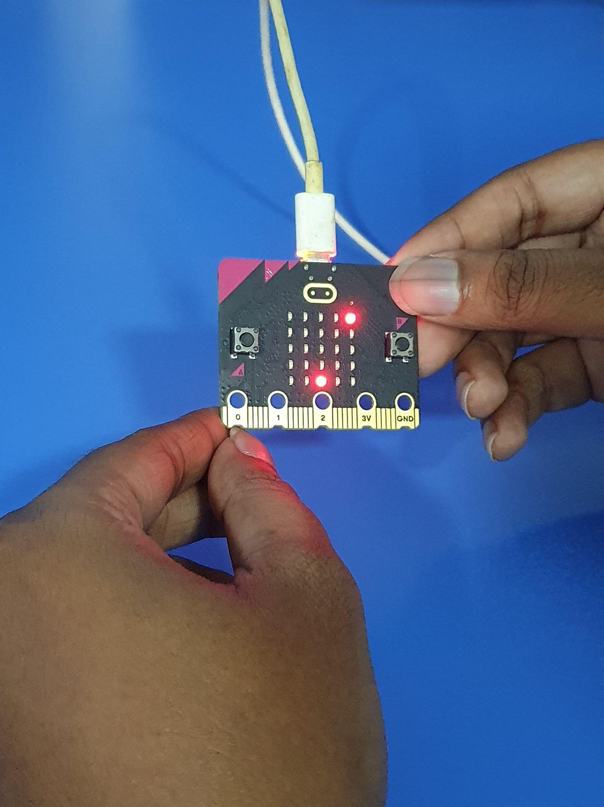

The button A is pressed in order to shoot bullets. The bullets look a bit dimmer than the player and the enemy and will move towards the top until it hits the edge or the enemy.

If the bullet hit the enemy then you get a score of +1 or you get a miss +1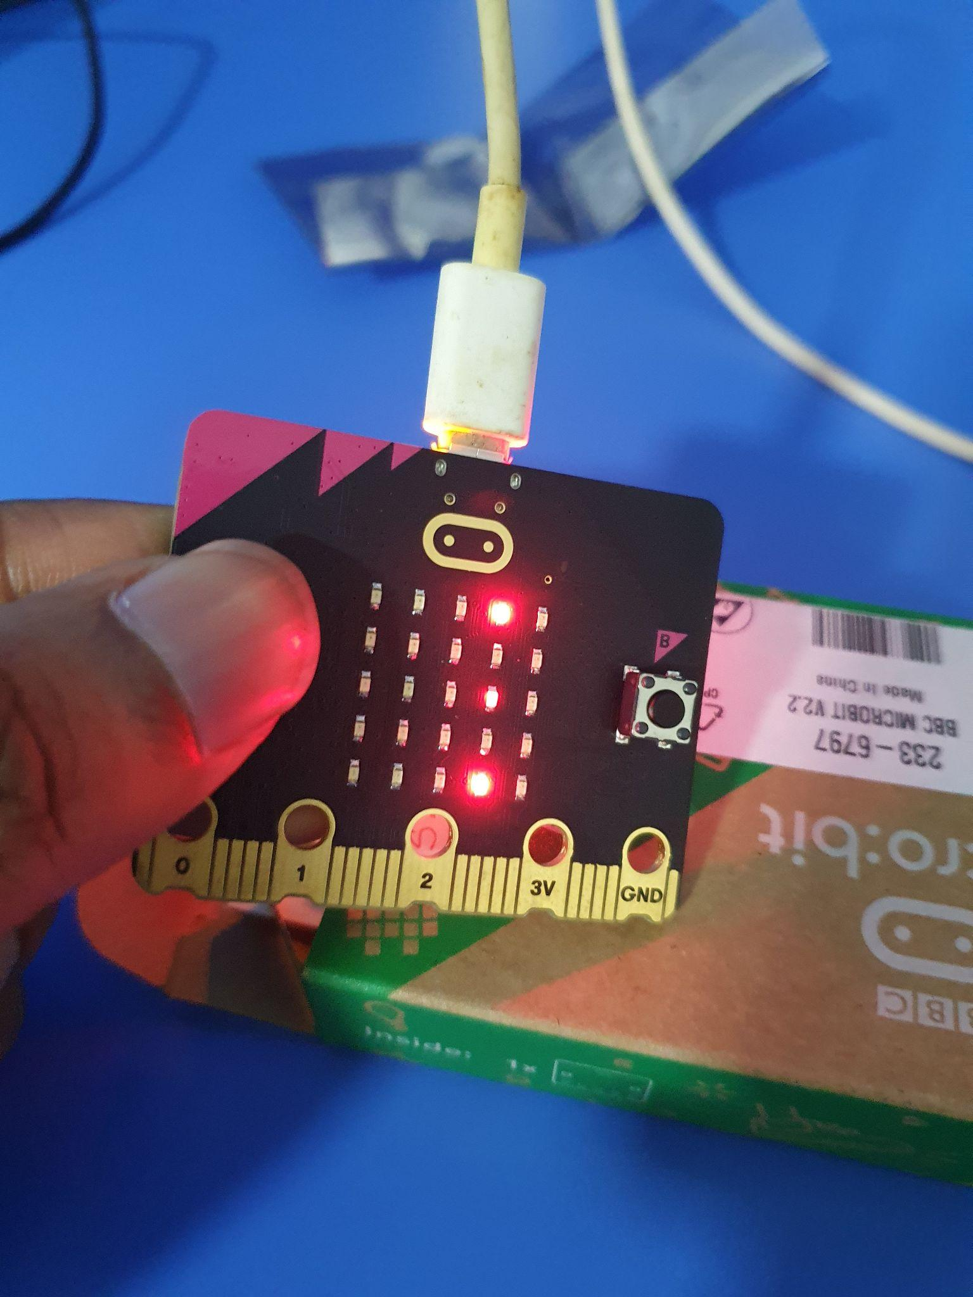

If the player manages to hit the enemy 4 times then you will see a message saying ‘CONGRATS’ and display your score.

If the player misses the enemy 4 times then you will see a game over screen along with your score.